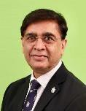
Jagmeet Makkar
FICS, FRINA, FIMarE(I), FHKIArb, AFIDRRMI, MCIArb, PMIoS
MSc (Energy, Trade & Finance) Bayes Business School (Earlier Cass)

Distinguished maritime professional with 40+ years of hands-on experience in shipping operations, commercial management, and dispute resolution. Combines technical expertise with deep commercial acumen in chartering, ship finance, and risk management. Currently serves as a panel arbitrator for leading global institutions while shaping the next generation of maritime professionals through academic leadership. A vast network in most maritime verticals through diverse experience.

Practicing Arbitrator, Accredited Mediator and Maritime Expert/Witness

Arbitration Bodies/Panels/Listings/Appointments

List / Panel Arbitrator

  - London Maritime Arbitrators Association (LMAA)
  - Hong Kong Maritime Arbitration Group (HKMAG)
  - Singapore Chamber of Maritime Arbitration (SCMA)
  - China Maritime Arbitration Commission (CMAC)
  - Hong Kong International Arbitration Centre (HKIAC)
  - Dubai International Arbitration Centre (DIAC)
  - Singapore International Arbitration Centre (SIAC)
  - Asia International Arbitration Centre (AIAC)
  - Shenzhen Court of International Arbitration (SCIA)
  - Borneo International Centre for Arbitration and Mediation (BICAM)
  - AALCO – Hong Kong Regional Arbitration Centre
  - Asia Pacific International Arbitration Centre (APIAC)
  - Japan Commercial Arbitration Association (JCAA)
  - India International Arbitration Centre (IIAC)

Accredited General Mediator with HKMAAL

Council Member of Hong Kong Institute of Arbitrators

Areas of Expertise (hands-on experience)

- Commercial
  - Charterparties (time; voyage; contracts of affreightment)
  - Bills of lading & letters of indemnity

- Ship management & ship building
  - Ship management contracts; ship damages, accidents, repairs, dry-docking and conversions, shipbuilding contracts

- Ship sale & purchase; ship finance & bareboat leases
  - Ship sale & purchase contracts (BIMCO/NSF/SSF)
  - Ship finance / lease agreements / JV (SHA)

Academic Qualifications & Training

- Arbitration and Mediation

  - Applied Arbitration for Fellows – Two-day course (CIArb) – September 2023
  - Accredited after Stage 2 Assessments and Stage 1 - 40 Hrs. General Mediation Training Course (Hong Kong Mediation Council) – August 2022 including Face-to-face role play exercises
  - Investment Law & Investor – State Mediator Training: (Department of Justice, ICSID, Asia Academy of International Law (AAIL) - 2018
  - HKIArb Fellowship Workshop by Prof. Anselmo Reyes SC [Award writing workshop - HKIArb in collaboration with LexisNexis] - 2017
  - Membership of CIArb through examinations – 2005

- Management & Marine Engineering

  - Pursuing online PhD (“Operational Innovations leading to Performance Enhancement in Shipping Industry”)
  - Master of Science (Energy Trade & Finance, Bayes Business School - City, University of London - earlier known as Cass Business School) 2016
  - Various Executive Education courses including:
    - Shipping Management (Indian Institute of Management, Ahmedabad) IIMA) – 2000
    - Strategic Marketing Management (Ross School of Business, University of Michigan, Ann Arbor) - 2006
  - Post-Graduation Certificate in Business Administration – OOUHK Hong Kong 2000
  - Indian Engineering Services (IES, Union Public Service Commission (UPSC)) - 1988
  - Graduation in Marine Engineering: DMET 1977-81 Batch

Professional Training Expertise (as a trainer)

(since 2017)

- Lead Faculty for Executive MBA program by Indian Institute of Management (IIM) Mumbai and The Company of Master Mariners India (CMMI)
- Approved faculty for introduction course with Chartered Institute of Arbitrators UK
- Part time lecturer with Hong Kong Polytechnic University
- Faculty mentor: Gujarat Maritime University
- Visiting lecturer: Indian Maritime University
- SkillsPlus Limited (Recognised Partner of the Institute of Chartered Shipbrokers)
  - Applied Commercial Shipping Courses
  - Shipping Disputes & Prevention (CPD by Law Society of Hong Kong)
    - Bills of Lading, LOIs, Contractual disputes, underperformance claims.
  - Introduction to International Arbitration (Faculty of CIArb)
  - Technical Shipping Courses (focus on project management)
  - Bespoke Courses (including Ship Finance, Shipping Contracts Management and Price Risk Management (FFAs & Bunkers) through Hedging (physical & derivatives)
  - Bespoke Training

Professional Institutes Listings

- FICS Fellow of Institute of Chartered Shipbrokers (UK)
- FHKIArb Fellow of Hong Kong Institute of Arbitrators (Hong Kong)
- AFIDRRMI Arbitration Fellow
International Dispute Resolution and Risk Management Institute (Hong Kong)
- FRINA Fellow of Royal Institution of Naval Architects (UK)
- FIMarE(I) Fellow of Institute of Marine Engineers (India)
- MCIArb Member of Chartered Institute of Arbitrators (UK)
- PMIoS Professional Member, Institute of Seatransport

Industry Positions

- Member, Maritime Services Training Board, VTC, Government of HKSAR 2025 onwards
- Council Member, Hong Kong Institute of Arbitrators
- Member, Planning Board, Indian Maritime University, 2024 onwards
- Member, Membership Committee (Global), ICS 2025-Present
- Controlling Council Member: Institute of Chartered Shipbrokers (ICS) 2020 - 2024
- Member, Education & Training Committee (Global), ICS 2017-2023
- Ambassador, Hong Kong: Baltic Expert Witness Association (BEWA)
- Sea Ambassador of ISWAN
- Chairman: Institute of Chartered Shipbrokers (ICS), Hong Kong Branch 2020 - 2024
- Chairman: Maritime & Logistics Arbitration Committee, HKCICA
- Advisor to Board: GIMAC under Gujarat Maritime University

Awards

- 2025, Rising Maritime Arbitrator of the Year (6th GLA Conference, Malaysia 2025)
- 2023, Mentor of the Year, Samudra Manthan Awards: 8th November 2023
- 2017, Exemplary Multi-Faceted Professional of the Year 2017, Sailor Today Awards
- 2016, Life Time Honorary Member – Beta Gamma Sigma Society, USA
- 2016, Cass Business School (now, Bayes Business School), First Class First
with distinction in MSc (Energy Trade & Finance)
- 1988, Indian Railway Services of Mechanical Engineers: PGM (Gold Medalist), Railway Staff College, Vadodara and stood first in the Diesel Course at IRIMEE, Jamalpur 1988-89
- Indian Engineering Service 1987 (5th Position in India)
- DMET 1977-81, President’s Gold Medalist in Marine Engineering; Institute of Naval Architects (EZ) Gold Medalist, Narottam Morarjee Prize

Industry Interaction & Publications

  - Publications
    - Regular contributor to various magazines and industry bodies such as eMarina, Seaview, Sailor Today, Bimco Review, Marine Engineers’ Review etc.
  - Conferences, Seminars. Webinars (Moderator, Speaker, Panellist)
    - Speaker in international conferences such as International Chamber of Shipping, Dry Shipping Summits, Marine Money, Coaltrans, Intercem, India Shipping Summit, Knect365, ACI (Active Communication International), FICCI, CII etc.
  - Technical Committees (Past member)
    - Lloyd`s Register of Shipping
    - Class NK
- Equality, Diversity & Inclusiveness
    - WISTA Hong Kong, Executive Committee & Board of Directors (Women’s International Shipping & Trade Association) 2020-2025 & Member
    - Diversity List 2017, Zubin Foundation

- Other committees
    - Indian Chambers of Commerce, Hong Kong
      - Member: India Committee
      - Member: Shipping Committee
    - Former Member: Joint Branch Committee of The Royal Institution of Naval Architects and The Institute of Marine Engineering, Science and Technology.
    - Former Co-opted Committee Member & Observer: Chartered Institute of Arbitrators, East Asia Branch

Career History

2024 to date Lead Faculty, Indian Institute of Management Mumbai & The Company of Master Mariners India for the two-year Executive MBA Program (Shipping, Ports and Logistics)

2017 to date Independent Arbitrator, Mediator, Shipping Expert and Expert Witness.

2021 to 2023 IMEI Chair at Indian Maritime University

2016 to date Director, SkillsPlus Pte Ltd, SkillsPlus Ltd. – Ship Finance & Bareboat Lease Consultant, Professional Training & Education

2013-2015 Co-Head of Freight and Global Head of Shipping Assets of Noble Chartering (Risk Management, Cargo Marketing, Chartering & Operations, Disputes & Prevention, Joint Ventures, New Buildings, Bareboat Leases, Sale & Purchase, overseeing third party ship managers).

2007-2013 Cargo Marketing, Chartering, New Building Ordering, Sale & Purchase and Overseeing Technical Management (Owners’ Rep.) with Noble Group as Executive Vice President of Noble Chartering

2002-2006 Market Analysis, New Building Ordering and Project Management of Dry Bulk Carriers and Cement Carriers, Ship Sale and Purchase, Technical Management with KC Maritime Ltd.

1995-2002 Technical Manager, New Buildings, Ship Repairs, Cement Carriers Conversion and Operations with KC Maritime Ltd.

1990-1995 New Building Supervisor for KC Maritime in Samsung, S. Korea 1990-1993 Second Engineer and, Chief Engineer on Product Tanker and Dry
Bulk Carriers (Great Eastern / KC Maritime Ltd.)

1988-1990 Indian Railway Service of Mechanical Engineers

1977-1988 Marine Engineering Education, World-wide sea-going service as Engineer Officer on Dry Bulk Carriers, Crude and Product Tankers, OBOs, Passenger Cruise Ship, Container Ships

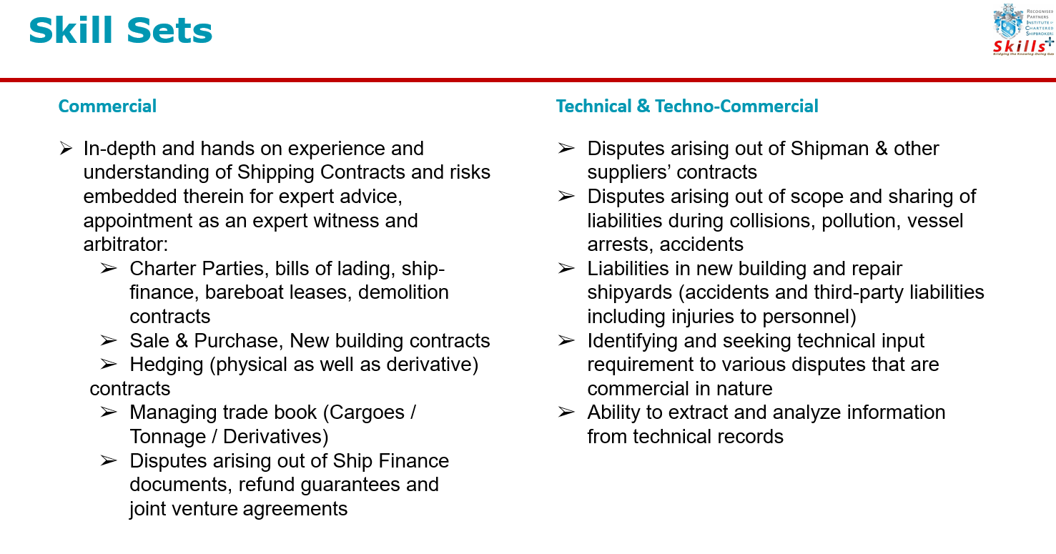

Jagmeet Makkar, FICS
Profile: Jagmeet Makkar, Tel: +852 95718832; E-mail: arbitration.jagmeet@gmail.com with cc info@skillsplus.sg
Address:
Jagmeet Singh Makkar
Flat A-B, Floor 29, Tower 20 (Mei Cheung Court)
South Horizons, Ap Lei Chau / Hong Kong

